**CA 2 Assignment Questions**

1. Suggest a general plan for analyzing the efficiency of recursive algorithm?

A) To find the Factorial of a number

B) Tower of honai.

1. Express the following f(n) using big oh.

A) f(n)=100n+5.

B)f(n)= 10n3+5

C) f(n) =6*2n+n2

1. Apply Brute Force String Matching algorithm and find the matching position of the pattern in the given text

TEXT : P**.**V**.**Sindhu_Won_Goldmedal_in_WBC

PATTERN: old

1. Apply Exhaustive Search procedure to find the shortest path for the given Travelling Salesperson Problem

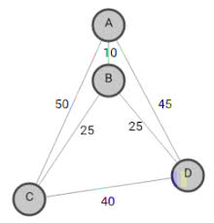

1. Apply Warshall’s algorithm to find the transitive closure of the digraph defined by the following adjacency matrix:

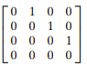

1. Explain with example a sorting algorithm that uses divide and conquer technique which divides the problem size by considering position. Give the corresponding algorithms and analyze the time complexity.
2. Solve the all-pairs shortest-path problem for the digraph with the following weight matrix:

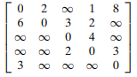

1. a. Apply the bottom-up dynamic programming algorithm to the following instance of the knapsack problem:

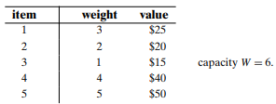

1. Define Master theorem and find the complexity for the given recurrence relation.

T(n)= 4T(n/2)+n2

T(n)= 2T(n/2)+n/logn

T(n)= T(n/2)+n2

1. Write the algorithm of knapsack problem for dynamic programming. Solve the following instance for the knapsack problem.

Items =4

{W1,w2,w3,w4}= {2,1,3,2}

{p1,p2,p3,p4}={12,10,20,15} Capacity=5

1. Write floyd’s algorithm and solve all pairs shortest path problem for the following graph.

